

|  |  |  |
| --- | --- | --- |
| **Supervisor** | SIR HARIS | |
| **Batch** | **2302B1** | |
| **Group** | **B** | |
| **Serial No.** | **Enrollment Number** | **Student Name** |
| 1. | Student1453035 | ABUBAKAR |
| 2. | Student1453038 | HAFIZ MUHAMMAD ZEESHAN |
| 3. | Student1431517 | USMAN ALI |
| 4. | Student1452380 | MUHAMMAD ANAS |

1.Home(index.html):

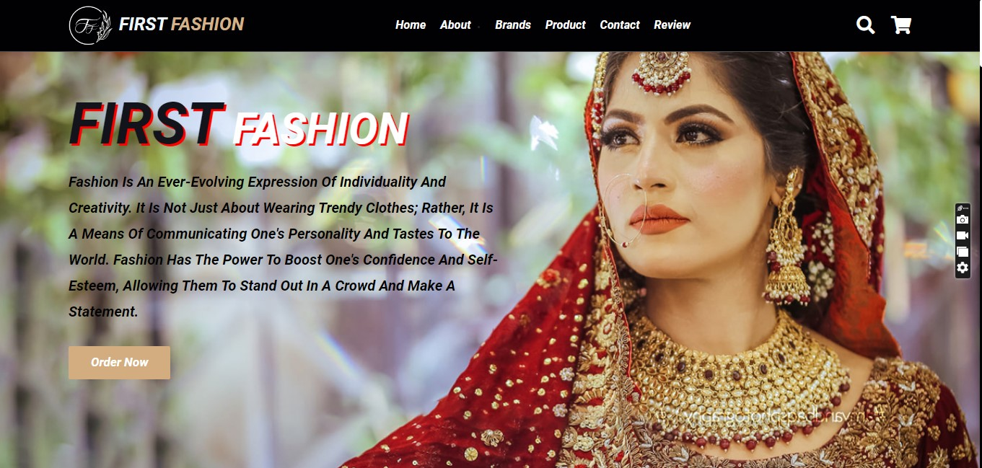

* By clicking the logo, the user will be taken to the homepage.
* Using the navbar, the user can navigate through various categories.

2.Navbar(index.html):



* There are four essentials listed here, and you will be redirected to the pages except for (Brands) and (Product), which are further classified.

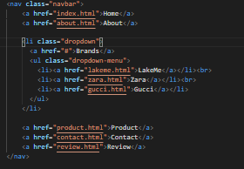

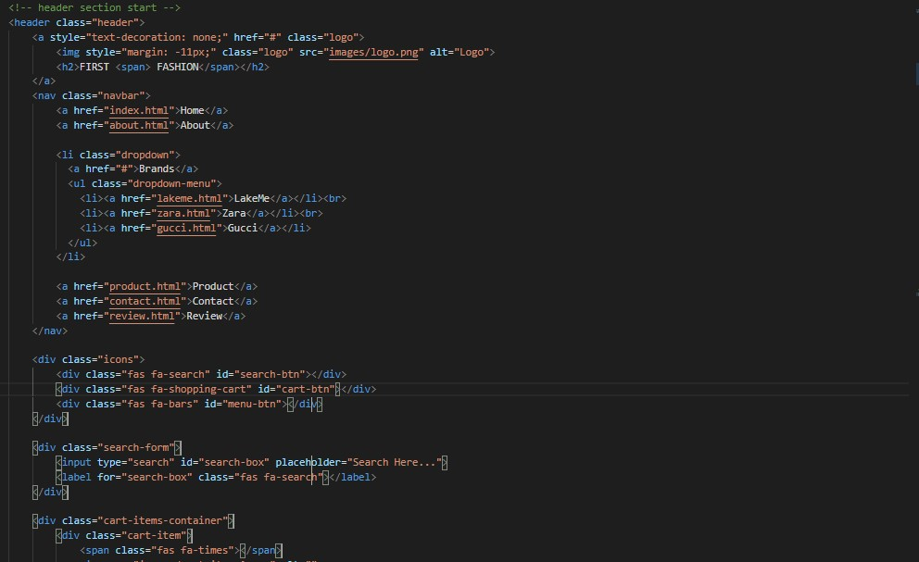

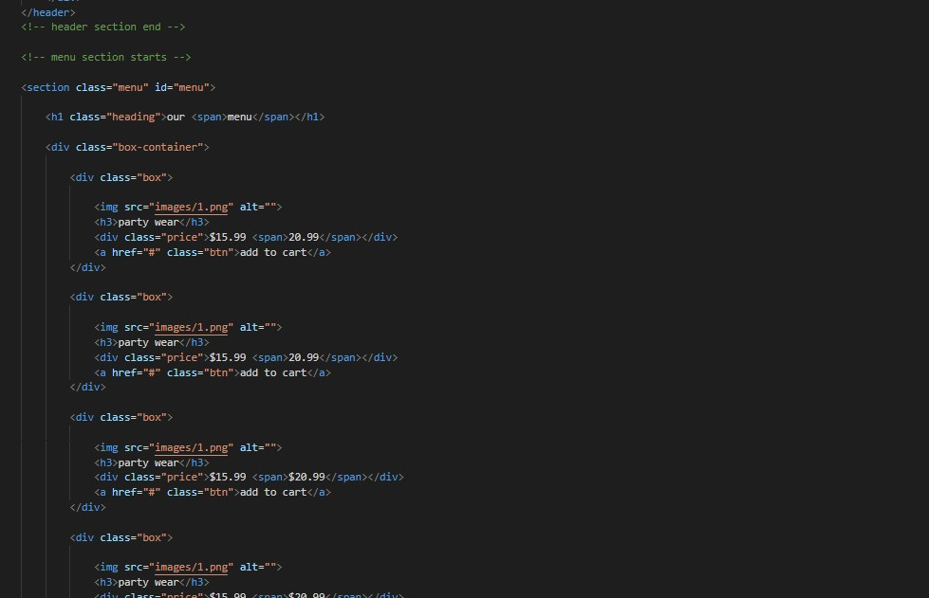

3.Add to cart(index.html):

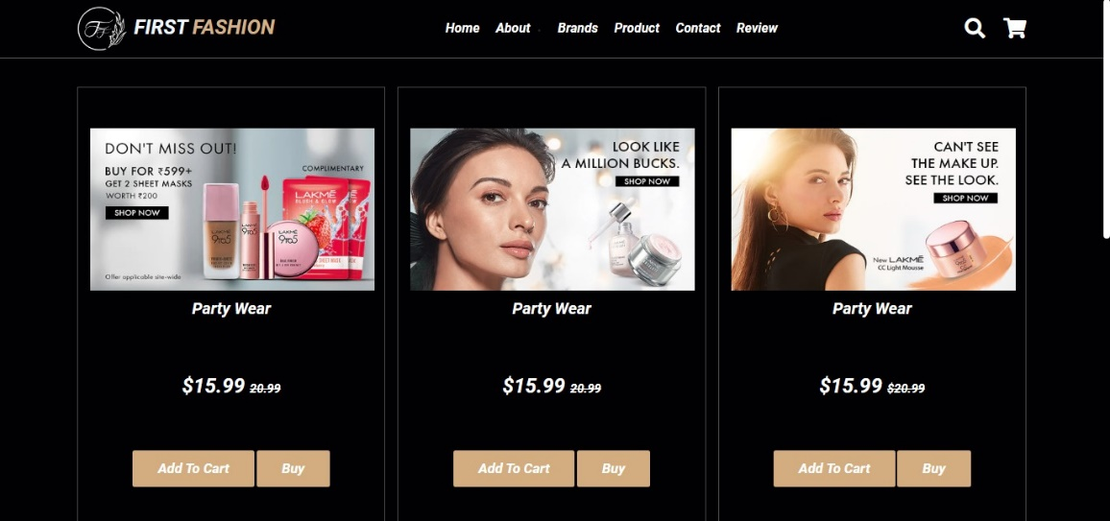

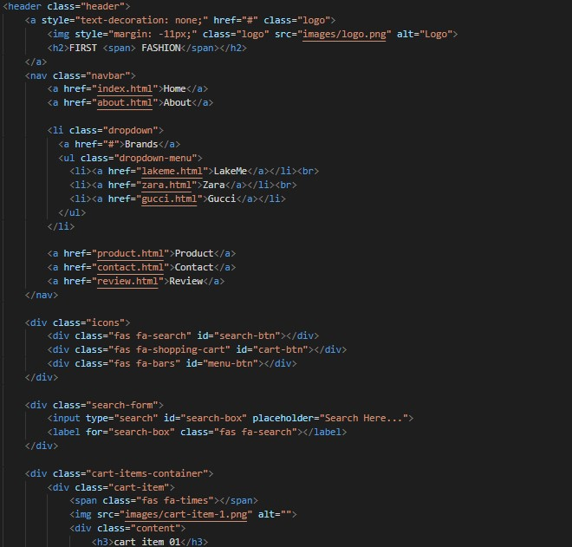

4.About Us(About.html):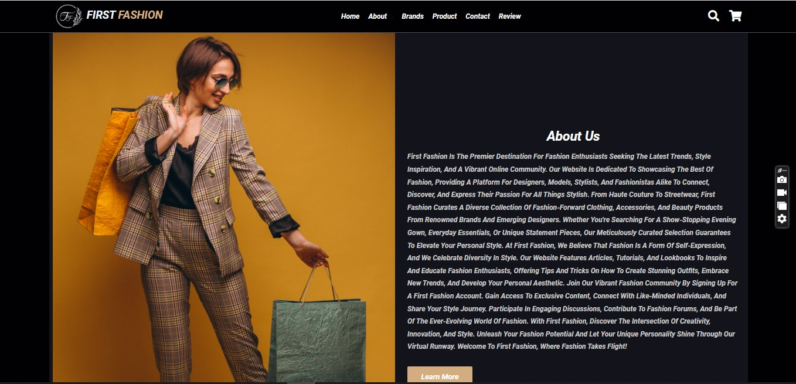

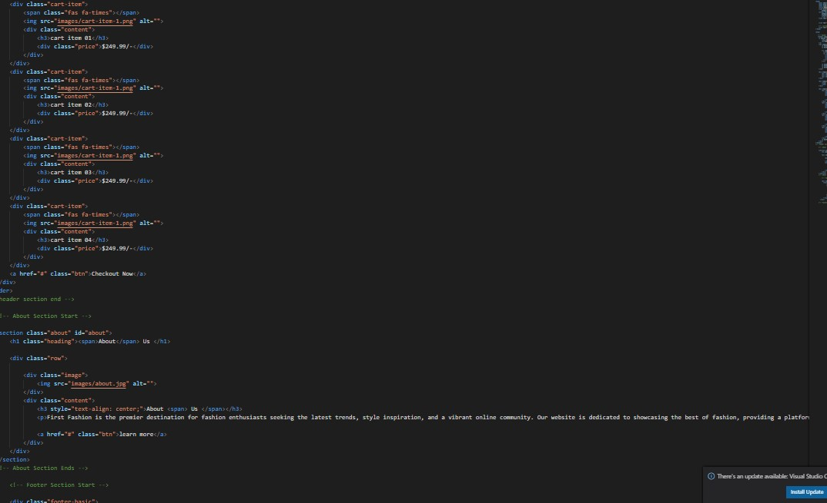

5.Contact Us(ContactUs.html):

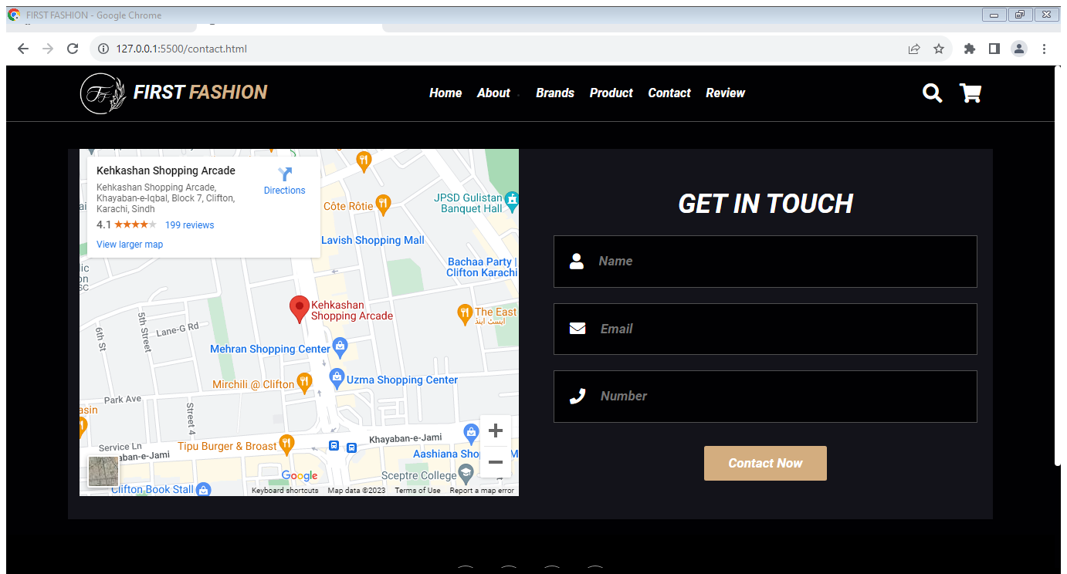

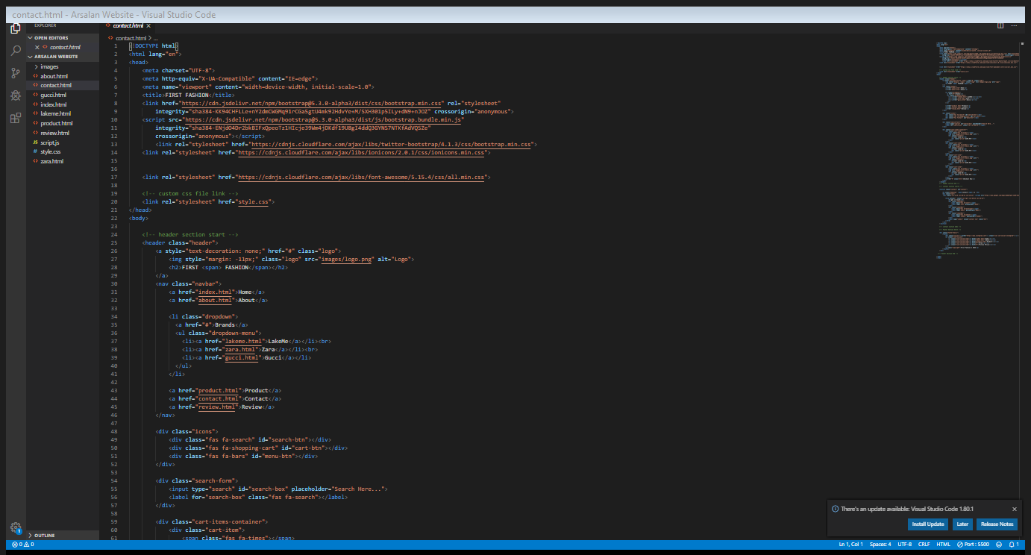

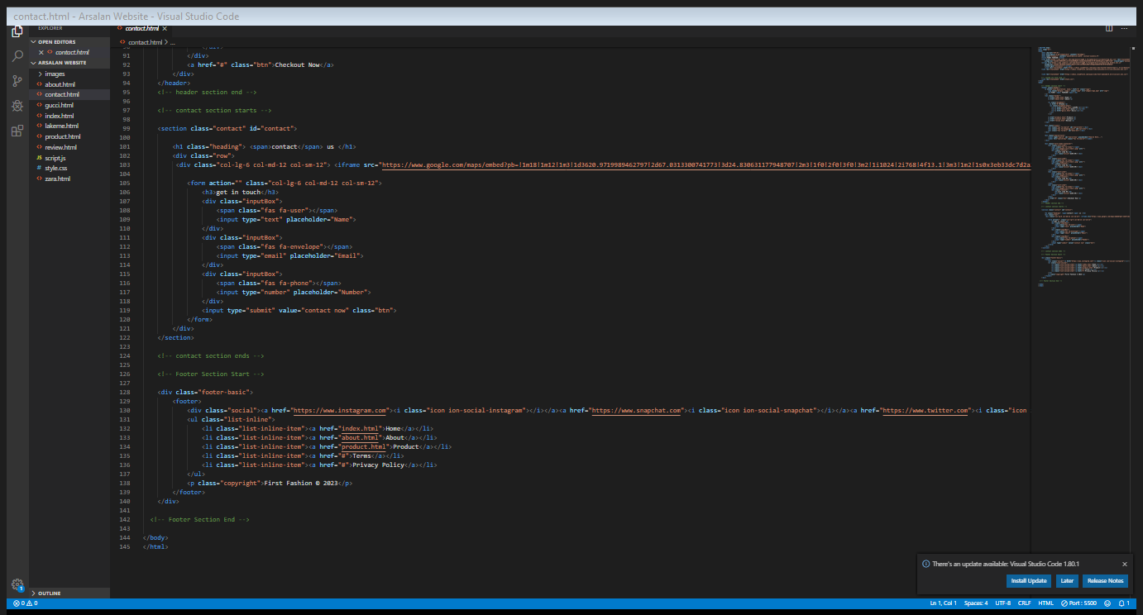

7.Footer:



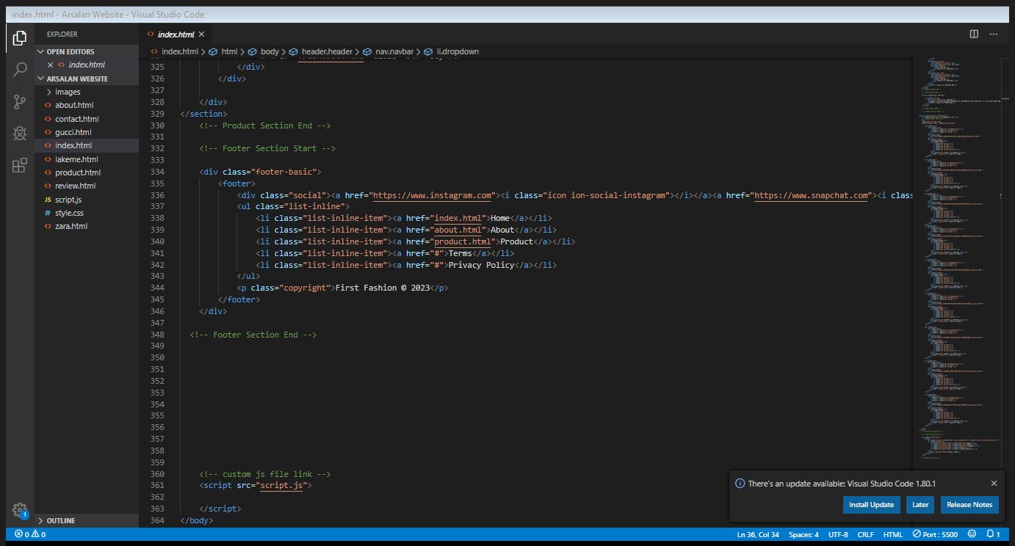

Summary:

The "First Fashion" Developer Guide is a comprehensive resource for building a visually stunning and dynamic fashion website. It emphasizes the importance of aesthetics, user experience (UX), and responsive design. The guide provides strategies for optimizing website performance, showcasing fashion collections, and integrating e-commerce solutions. It also highlights the significance of social and community elements to engage fashion-conscious audiences effectively. By following this guide, developers can create an exceptional fashion website that combines style, functionality, and a seamless user experience to establish a strong online presence in the fashion industry.